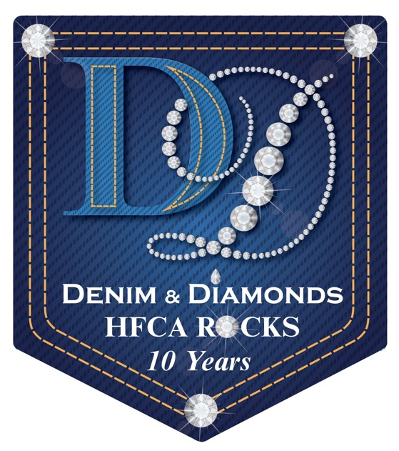
Denim & Diamond News

Please welcome our 2012 Gala Sponsors

Marquise Diamond Sponsor:
Heart Diamond Sponsor
Denim Sponsors
Mr. & Mrs. Steven Miller
Biltmore Country Club

Our entertainment for the evening is
“The Business”

Committee
WHAT: Denim & Diamonds
HFCA Rocks 10 Year Celebration
WHEN: Saturday, May 19th, 2012
WHERE: The Meadows Club
2950 W. Golf Road, Rolling Meadows

Welcome to our first edition of the Denim & Diamond News.
We are just 71 days away from our annual spring gala. This is our
10 Year Anniversary Event Celebration. This is a night that you don’t
want to miss. Please mark your calendars and save the date for
May 19, 2012 at The Meadows Club located in Rolling Meadows, IL.
Invitations are coming soon.

Let us answer what everyone is asking about “What is Denim &
Diamonds”. It is this years’ Gala attire. Yes, you can wear casual or formal wear worn together, celebrating the best of both worlds. Consider it casual elegance,
with glitz and glamour, no rules right or wrong. We want you to be down to earth and glamorous at the same time as HFCA Rocks 10 years!

It is not too late to help the gala committee obtain our goals. It takes
over 75 volunteers to plan, organize and run the gala smoothly. Please
find it in your heart to consider lending your expertise. Please contact Diana Levin at kdl1987@aol.com or Rose Jusi at rujusi2@aol.com with any questions.

Your gala committee is still looking for sponsors. Available is the Black
Diamond Level in which we give away the front cover to our gala event program. We also have our Trillion and Emerald Diamond Level sponsors
available. We are always looking for Heart and Denim sponsors too.

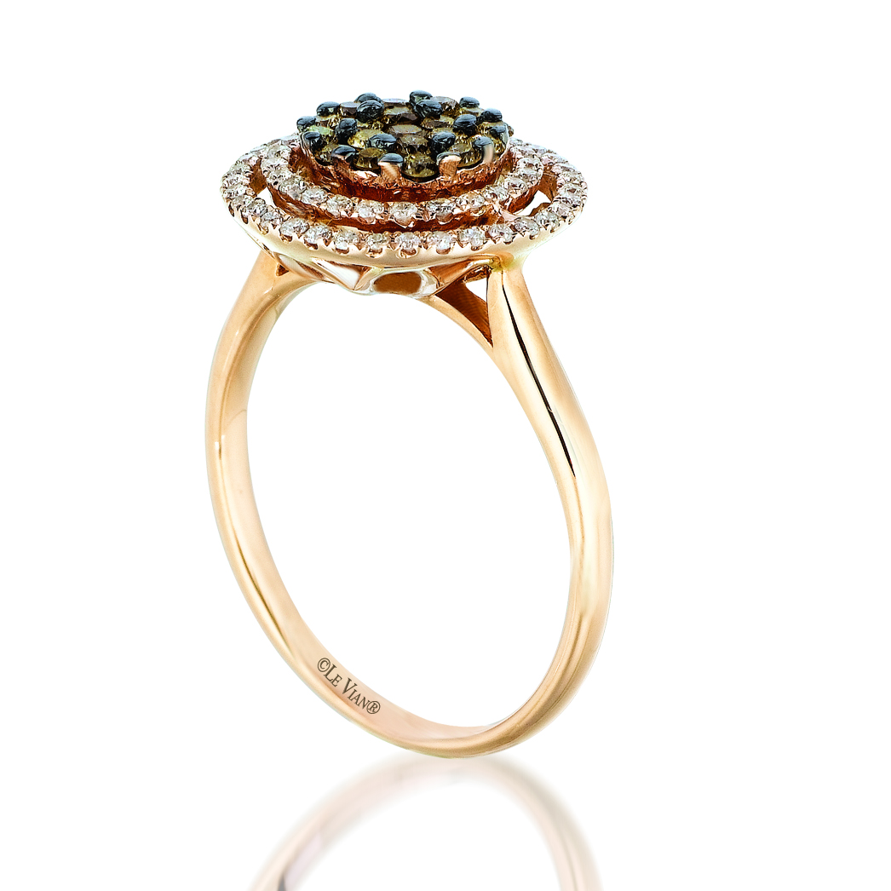
Exciting this year, is our Le Vian Chocolatier Diamond Ring Raffle. We
will have $25 chocolate candy bars for your purchase for a chance to win this
beautiful ring donated by Long & Company located in downtown Barrington.

Don’t forget to visit us at www.hfcagala.com
Like us on HFCA 2012 Gala

